**Welcome to Day #3 of CGCC!**

Every day we will have a GitHub repository page that outlines each day and the activities that we will complete. We will also provide all homework on these pages.

Feel free to browse the other days to see what is coming up!

As always, let us know if you need any help or have any questions.

*Link to Camp GitHub*: <https://github.com/paigerodeghero/ClemsonGameCodingCamp/tree/master/2021>

**Day 3: **descriptive title here\*\***

**SCHEDULE:**

* Instructors start the video call
* Going over homework from day 2
* Short review of players and player interactions
* Introduction to Scenes
* Students begin to make their own scenes for Flappy Bird
* Break
* Questions
* Introduce group game
* Play Among us with instructors
* Guest Speaker
* Questions
* Introduction to pixel art
* Students break into groups and begin designing characters
* Additional Questions
* Introduce Homework

**INSTRUCTION**: Going over last night's homework assignment expectations (approximately 5 minutes)

Have each student group go over their homework with the group (2-3 minutes each)

**INSTRUCTION**: Instructors review players and player interactions from Day 2 (approximately 10 min)

**ACTIVITY**: full camp activity (approximately 15 minutes)

Students demonstrate what they have and ask any questions about player interactions

**INSTRUCTION**: Scenes – Walls and Textures (30 min)

* Have students download a tileset for flappy bird
* Change the aspect ratio of the game scence
  + Project > Project Settings > Display > Window
  + Width: 256
  + Height: 512
  + 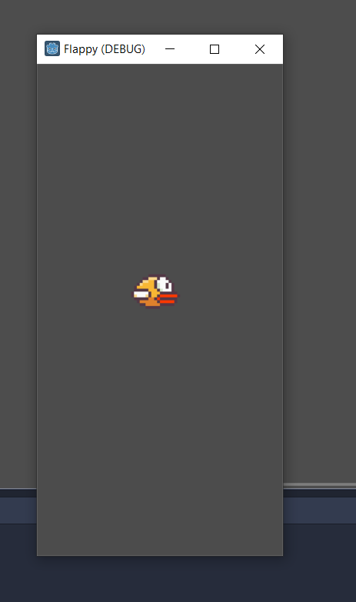
* Load the background
  + Create a new sprite on World – right click the background node to add a child node and sprite
  + Rename Sprite to “Background”
  + In the inspector tab add a texture from the flappy bird tileset
  + Resize using the orange handles to your scene size
  + 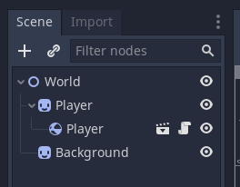
* Add a camera to the word scene Camera2D
  + Set anchor mode to top left
  + Set to current
* Now instantiate the player scene in the camera scene
  + Right-click Camera2D > Instance Child Scene
  + Right click the Player under camera2d and check “load as placeholder”
* Tutorial I am going to base mine off of
  + <https://www.youtube.com/watch?v=HuQgfy2IV9I&list=PLv3l-oZCXaql20IlPe7gfBEzomnPSLekY&index=3>
* [draft] add ground sprites and wall sprites
* [draft] spawning wall sprites
* [draft] Show character moving through wall sprites and ground sprites – ask students what they think needs to happen now
* [draft] Show them how to add collisions
* [draft] Show the character now working within the bounds of the walls created

**~~ACTIVITY~~**~~: solo and think-team-share (approximately 30 minutes)~~

~~Students work on creating their own scene~~

15 MINUTE BREAK

**INSTRUCTION**: Instructors introduce the game “Among Us” (approx. 5 min)

**ACTIVITY**: full camp activity (approximately 25 minutes)

Break into groups of no more than 10 with random number assigner

Play “Among Us”.

**~~INSTRUCTION~~**~~: Guest Speaker? (30-45 min)~~

**INSTRUCTION**: Introducing Making your own pixel art with (30-45 min)

* Go over where to find free pixel art
  + Kenny.nl
  + Itch.io
  + Camp coordinator made assets?
* Download some of these that you think are useful or cool looking to get an idea of what you may want to pull inspiration from
  + Ask 3-4 campers what they picked and why they thought it was cool
* Begin instructions on character and game development
  + Think about the type of game you want to make!
  + Say my game is a 2D top-down RPG where the player goes on a quest to slay a dragon that’s been threatening the local village for years. I now want to prototype some of the aspects of the game like combat.
  + **Prototype example plan for 2D RPG attack prototype**
    - Start by creating a basic scene and playing the play sprite inside.
    - Add keyboard controls to the player sprite.
    - Create a collide-able object and have it work correctly with the player (the player should not be able to move through a rock for instance
    - Create a weapon sprite on character.
    - Create attacking hitbox / button control (animations can be a different beast that we’ll save for a different day, for now, just have it play a sound and change from one sprite to another like a “2 frame animation”)
    - Create an enemy sprite and add collision.
    - Create a means to defeat an enemy (if the player hits the attack and the collision of the sword hits the collision of the enemy, remove the enemy object)
  + Use steps similar to these to create a basic prototype for your game.
    - Think about the high-level overview of the game
    - Sketch up your main characters
    - Sketch up a mob or enemy
  + Be sure to ask questions when needed.
* Now that you have a character or some things for a scene in mind how do you make it a reality?
* <https://www.piskelapp.com/>
* Hilight features of the app
  + Lighten/darken
  + Mirror tool
* Go over basic drawing concepts
  + Shading and highlights with a sphere
  + Not everything will be perfect!
  + 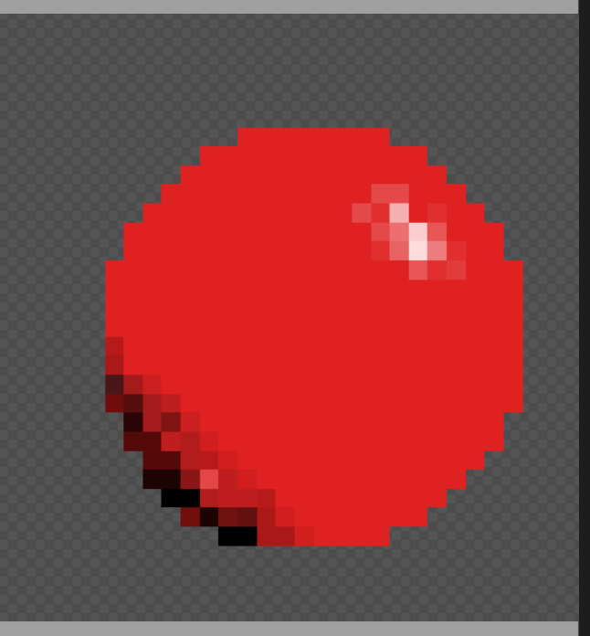
* Exporting images
* Animations

**ACTIVITY:** Think-Team-Share Brainstorming characters for game (approximately 25 minutes)

Students break into their groups to begin brain storming character ideas for their final game

**INSTRUCTION**: Ask if there are any final questions for the day before introducing homework

**HOMEWORK:** Continue Brainstroming characters

* Continue to think about your characters and any other NPCs or objects that you would want in your final game
* Be prepared to talk about your Flappy Bird and final game on day 4
  + (1) Be ready to demo the game via screen sharing
  + (2) Explain what your game will be about
  + (3) Write out the game elements
    - Goal
    - Story
    - Rules
    - Players
    - Player interactions